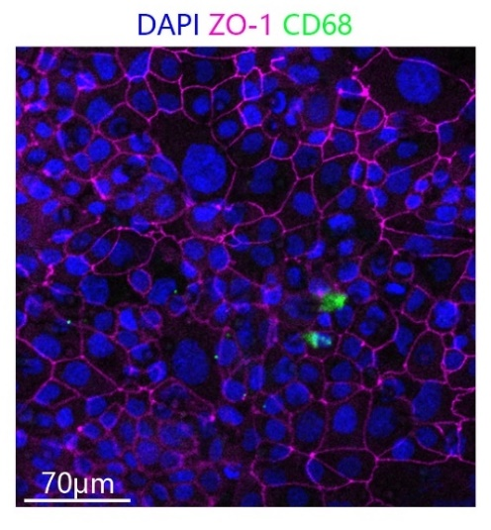
Supplementary Fig. 1. Marker expression of the epithelial cell layer of the human lung-on-chip model. Expression of epithelial marker zona occludens-1 (purple) and for macrophage marker CD68 (green), as confirmed by immunofluorescence staining. Nuclei were stained with 4′,6-diamidin-2-phenylindol (DAPI), shown in blue. Lower panel shows images in shading projection/view. Scale bar represents 70 μm. N = 3.

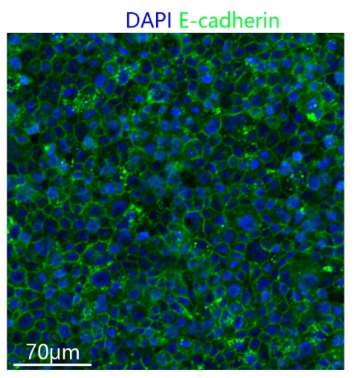
Supplementary Fig. 2. Expression of epithelial marker E-cadherin (green), as confirmed by immunofluorescence staining. Nuclei were stained with 4′,6-diamidin-2-phenylindol (DAPI), shown in blue. Scale bar represents 70 μm. N = 3.

Supplementary Fig. 3. Expression of epithelial marker surfactant protein A (SP-A) (green), as confirmed by immunofluorescence staining. Nuclei were stained with 4′,6-diamidin-2-phenylindol (DAPI), shown in blue. Scale bar represents 70 μm. N = 3.

A B
Supplementary Fig. 4. Analysis of communication network of secreted signals between influenza A virus-infected and uninfected groups. (A) Communication network of secreted signals between B cells and CD4 T cells in influenza A virus-infected group. (B) Communication network of secreted signals between B cells and CD4 T cells in the control group. The dotted ones in the figure represent the significance of the p-value of the communication effect, and the dot’s color represents the communication intensity.

